TP Blockchain :

A,b,c,d.

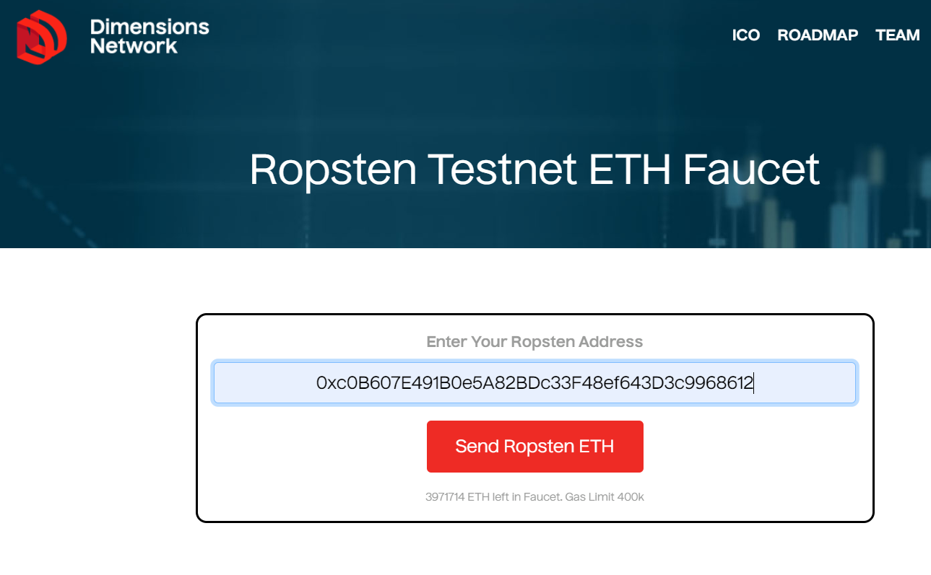

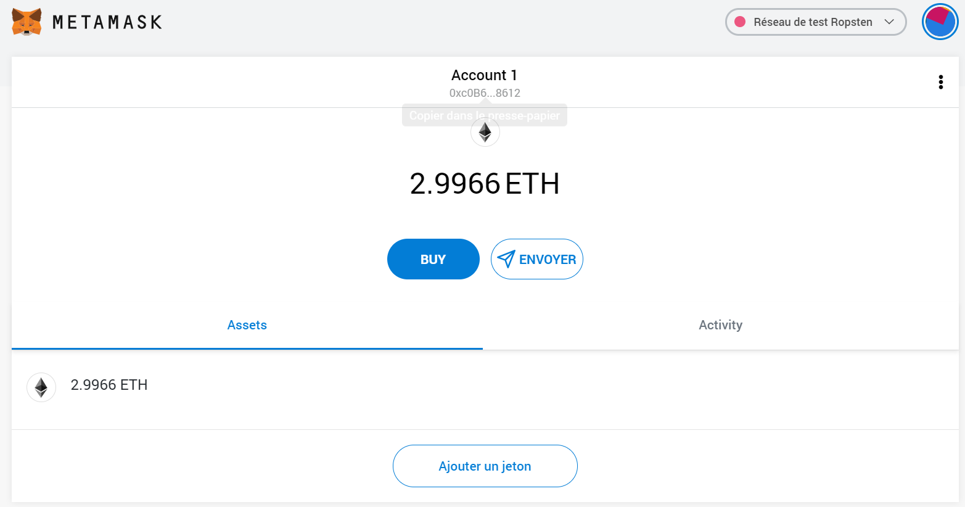

e.

Etherscan des ether recu : <https://ropsten.etherscan.io/tx/0x05acea88c85603e1e25caddb2517345990de0ae43eb122b0c541c2493b35b24b>

g.

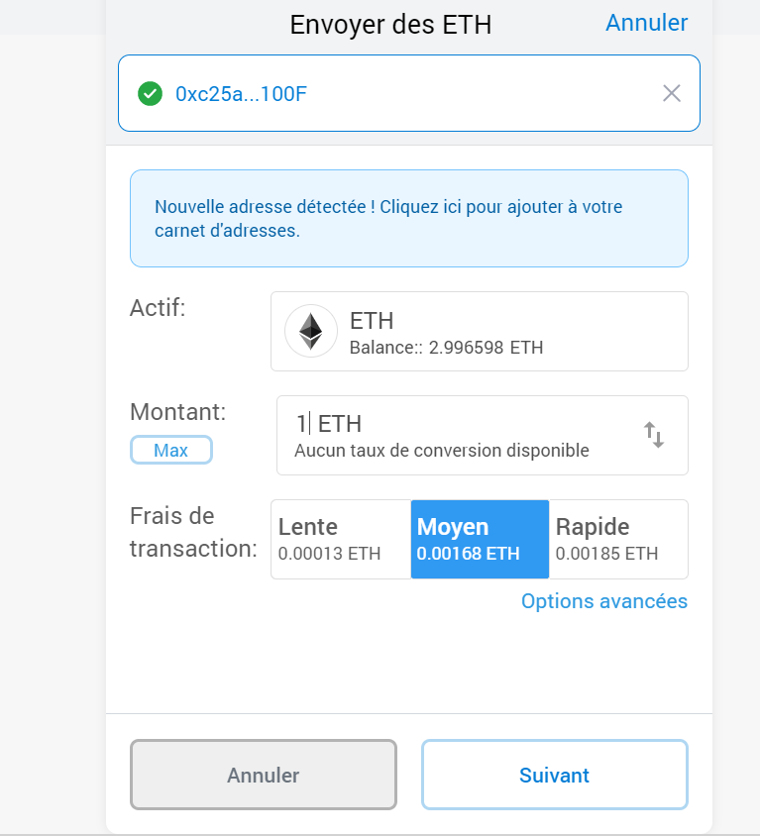

Etherscan, ether envoyé : <https://ropsten.etherscan.io/tx/0x121510fde84fc3b8d36830ba595a89d73c60f19ef6ef752dbba5162c4f039b5a>

H,i,j,k.

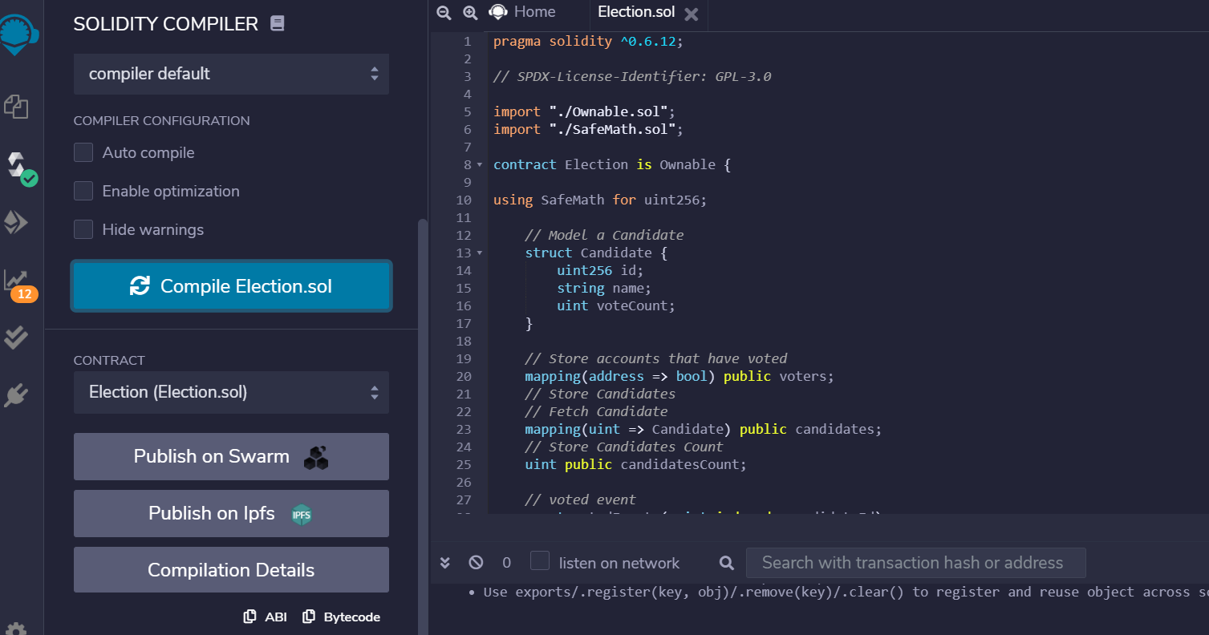

Abi : [

{

"anonymous": false,

"inputs": [

{

"indexed": true,

"internalType": "address",

"name": "previousOwner",

"type": "address"

},

{

"indexed": true,

"internalType": "address",

"name": "newOwner",

"type": "address"

}

],

"name": "OwnershipTransferred",

"type": "event"

},

{

"anonymous": false,

"inputs": [

{

"indexed": true,

"internalType": "uint256",

"name": "_candidateId",

"type": "uint256"

}

],

"name": "votedEvent",

"type": "event"

},

{

"inputs": [

{

"internalType": "string",

"name": "_name",

"type": "string"

}

],

"name": "addCandidate",

"outputs": [],

"stateMutability": "nonpayable",

"type": "function"

},

{

"inputs": [

{

"internalType": "uint256",

"name": "",

"type": "uint256"

}

],

"name": "candidates",

"outputs": [

{

"internalType": "uint256",

"name": "id",

"type": "uint256"

},

{

"internalType": "string",

"name": "name",

"type": "string"

},

{

"internalType": "uint256",

"name": "voteCount",

"type": "uint256"

}

],

"stateMutability": "view",

"type": "function"

},

{

"inputs": [],

"name": "candidatesCount",

"outputs": [

{

"internalType": "uint256",

"name": "",

"type": "uint256"

}

],

"stateMutability": "view",

"type": "function"

},

{

"inputs": [],

"name": "owner",

"outputs": [

{

"internalType": "address",

"name": "",

"type": "address"

}

],

"stateMutability": "view",

"type": "function"

},

{

"inputs": [

{

"internalType": "address",

"name": "newOwner",

"type": "address"

}

],

"name": "transferOwnership",

"outputs": [],

"stateMutability": "nonpayable",

"type": "function"

},

{

"inputs": [

{

"internalType": "uint256",

"name": "_candidateId",

"type": "uint256"

}

],

"name": "vote",

"outputs": [],

"stateMutability": "nonpayable",

"type": "function"

},

{

"inputs": [

{

"internalType": "address",

"name": "",

"type": "address"

}

],

"name": "voters",

"outputs": [

{

"internalType": "bool",

"name": "",

"type": "bool"

}

],

"stateMutability": "view",

"type": "function"

}

]

Bytecode : {

"linkReferences": {},

"object": "",

"opcodes": "PUSH1 0x80 PUSH1 0x40 MSTORE CALLVALUE DUP1 ISZERO PUSH2 0x10 JUMPI PUSH1 0x0 DUP1 REVERT JUMPDEST POP CALLER PUSH1 0x0 DUP1 PUSH2 0x100 EXP DUP2 SLOAD DUP2 PUSH20 0xFFFFFFFFFFFFFFFFFFFFFFFFFFFFFFFFFFFFFFFF MUL NOT AND SWAP1 DUP4 PUSH20 0xFFFFFFFFFFFFFFFFFFFFFFFFFFFFFFFFFFFFFFFF AND MUL OR SWAP1 SSTORE POP PUSH2 0x8AB DUP1 PUSH2 0x60 PUSH1 0x0 CODECOPY PUSH1 0x0 RETURN INVALID PUSH1 0x80 PUSH1 0x40 MSTORE CALLVALUE DUP1 ISZERO PUSH2 0x10 JUMPI PUSH1 0x0 DUP1 REVERT JUMPDEST POP PUSH1 0x4 CALLDATASIZE LT PUSH2 0x7D JUMPI PUSH1 0x0 CALLDATALOAD PUSH1 0xE0 SHR DUP1 PUSH4 0x462E91EC GT PUSH2 0x5B JUMPI DUP1 PUSH4 0x462E91EC EQ PUSH2 0x183 JUMPI DUP1 PUSH4 0x8DA5CB5B EQ PUSH2 0x23E JUMPI DUP1 PUSH4 0xA3EC138D EQ PUSH2 0x272 JUMPI DUP1 PUSH4 0xF2FDE38B EQ PUSH2 0x2CC JUMPI PUSH2 0x7D JUMP JUMPDEST DUP1 PUSH4 0x121B93F EQ PUSH2 0x82 JUMPI DUP1 PUSH4 0x2D35A8A2 EQ PUSH2 0xB0 JUMPI DUP1 PUSH4 0x3477EE2E EQ PUSH2 0xCE JUMPI JUMPDEST PUSH1 0x0 DUP1 REVERT JUMPDEST PUSH2 0xAE PUSH1 0x4 DUP1 CALLDATASIZE SUB PUSH1 0x20 DUP2 LT ISZERO PUSH2 0x98 JUMPI PUSH1 0x0 DUP1 REVERT JUMPDEST DUP2 ADD SWAP1 DUP1 DUP1 CALLDATALOAD SWAP1 PUSH1 0x20 ADD SWAP1 SWAP3 SWAP2 SWAP1 POP POP POP PUSH2 0x310 JUMP JUMPDEST STOP JUMPDEST PUSH2 0xB8 PUSH2 0x42F JUMP JUMPDEST PUSH1 0x40 MLOAD DUP1 DUP3 DUP2 MSTORE PUSH1 0x20 ADD SWAP2 POP POP PUSH1 0x40 MLOAD DUP1 SWAP2 SUB SWAP1 RETURN JUMPDEST PUSH2 0xFA PUSH1 0x4 DUP1 CALLDATASIZE SUB PUSH1 0x20 DUP2 LT ISZERO PUSH2 0xE4 JUMPI PUSH1 0x0 DUP1 REVERT JUMPDEST DUP2 ADD SWAP1 DUP1 DUP1 CALLDATALOAD SWAP1 PUSH1 0x20 ADD SWAP1 SWAP3 SWAP2 SWAP1 POP POP POP PUSH2 0x435 JUMP JUMPDEST PUSH1 0x40 MLOAD DUP1 DUP5 DUP2 MSTORE PUSH1 0x20 ADD DUP1 PUSH1 0x20 ADD DUP4 DUP2 MSTORE PUSH1 0x20 ADD DUP3 DUP2 SUB DUP3 MSTORE DUP5 DUP2 DUP2 MLOAD DUP2 MSTORE PUSH1 0x20 ADD SWAP2 POP DUP1 MLOAD SWAP1 PUSH1 0x20 ADD SWAP1 DUP1 DUP4 DUP4 PUSH1 0x0 JUMPDEST DUP4 DUP2 LT ISZERO PUSH2 0x146 JUMPI DUP1 DUP3 ADD MLOAD DUP2 DUP5 ADD MSTORE PUSH1 0x20 DUP2 ADD SWAP1 POP PUSH2 0x12B JUMP JUMPDEST POP POP POP POP SWAP1 POP SWAP1 DUP2 ADD SWAP1 PUSH1 0x1F AND DUP1 ISZERO PUSH2 0x173 JUMPI DUP1 DUP3 SUB DUP1 MLOAD PUSH1 0x1 DUP4 PUSH1 0x20 SUB PUSH2 0x100 EXP SUB NOT AND DUP2 MSTORE PUSH1 0x20 ADD SWAP2 POP JUMPDEST POP SWAP5 POP POP POP POP POP PUSH1 0x40 MLOAD DUP1 SWAP2 SUB SWAP1 RETURN JUMPDEST PUSH2 0x23C PUSH1 0x4 DUP1 CALLDATASIZE SUB PUSH1 0x20 DUP2 LT ISZERO PUSH2 0x199 JUMPI PUSH1 0x0 DUP1 REVERT JUMPDEST DUP2 ADD SWAP1 DUP1 DUP1 CALLDATALOAD SWAP1 PUSH1 0x20 ADD SWAP1 PUSH5 0x100000000 DUP2 GT ISZERO PUSH2 0x1B6 JUMPI PUSH1 0x0 DUP1 REVERT JUMPDEST DUP3 ADD DUP4 PUSH1 0x20 DUP3 ADD GT ISZERO PUSH2 0x1C8 JUMPI PUSH1 0x0 DUP1 REVERT JUMPDEST DUP1 CALLDATALOAD SWAP1 PUSH1 0x20 ADD SWAP2 DUP5 PUSH1 0x1 DUP4 MUL DUP5 ADD GT PUSH5 0x100000000 DUP4 GT OR ISZERO PUSH2 0x1EA JUMPI PUSH1 0x0 DUP1 REVERT JUMPDEST SWAP2 SWAP1 DUP1 DUP1 PUSH1 0x1F ADD PUSH1 0x20 DUP1 SWAP2 DIV MUL PUSH1 0x20 ADD PUSH1 0x40 MLOAD SWAP1 DUP2 ADD PUSH1 0x40 MSTORE DUP1 SWAP4 SWAP3 SWAP2 SWAP1 DUP2 DUP2 MSTORE PUSH1 0x20 ADD DUP4 DUP4 DUP1 DUP3 DUP5 CALLDATACOPY PUSH1 0x0 DUP2 DUP5 ADD MSTORE PUSH1 0x1F NOT PUSH1 0x1F DUP3 ADD AND SWAP1 POP DUP1 DUP4 ADD SWAP3 POP POP POP POP POP POP POP SWAP2 SWAP3 SWAP2 SWAP3 SWAP1 POP POP POP PUSH2 0x4F7 JUMP JUMPDEST STOP JUMPDEST PUSH2 0x246 PUSH2 0x573 JUMP JUMPDEST PUSH1 0x40 MLOAD DUP1 DUP3 PUSH20 0xFFFFFFFFFFFFFFFFFFFFFFFFFFFFFFFFFFFFFFFF AND DUP2 MSTORE PUSH1 0x20 ADD SWAP2 POP POP PUSH1 0x40 MLOAD DUP1 SWAP2 SUB SWAP1 RETURN JUMPDEST PUSH2 0x2B4 PUSH1 0x4 DUP1 CALLDATASIZE SUB PUSH1 0x20 DUP2 LT ISZERO PUSH2 0x288 JUMPI PUSH1 0x0 DUP1 REVERT JUMPDEST DUP2 ADD SWAP1 DUP1 DUP1 CALLDATALOAD PUSH20 0xFFFFFFFFFFFFFFFFFFFFFFFFFFFFFFFFFFFFFFFF AND SWAP1 PUSH1 0x20 ADD SWAP1 SWAP3 SWAP2 SWAP1 POP POP POP PUSH2 0x597 JUMP JUMPDEST PUSH1 0x40 MLOAD DUP1 DUP3 ISZERO ISZERO DUP2 MSTORE PUSH1 0x20 ADD SWAP2 POP POP PUSH1 0x40 MLOAD DUP1 SWAP2 SUB SWAP1 RETURN JUMPDEST PUSH2 0x30E PUSH1 0x4 DUP1 CALLDATASIZE SUB PUSH1 0x20 DUP2 LT ISZERO PUSH2 0x2E2 JUMPI PUSH1 0x0 DUP1 REVERT JUMPDEST DUP2 ADD SWAP1 DUP1 DUP1 CALLDATALOAD PUSH20 0xFFFFFFFFFFFFFFFFFFFFFFFFFFFFFFFFFFFFFFFF AND SWAP1 PUSH1 0x20 ADD SWAP1 SWAP3 SWAP2 SWAP1 POP POP POP PUSH2 0x5B7 JUMP JUMPDEST STOP JUMPDEST PUSH1 0x1 PUSH1 0x0 CALLER PUSH20 0xFFFFFFFFFFFFFFFFFFFFFFFFFFFFFFFFFFFFFFFF AND PUSH20 0xFFFFFFFFFFFFFFFFFFFFFFFFFFFFFFFFFFFFFFFF AND DUP2 MSTORE PUSH1 0x20 ADD SWAP1 DUP2 MSTORE PUSH1 0x20 ADD PUSH1 0x0 KECCAK256 PUSH1 0x0 SWAP1 SLOAD SWAP1 PUSH2 0x100 EXP SWAP1 DIV PUSH1 0xFF AND ISZERO PUSH2 0x367 JUMPI PUSH1 0x0 DUP1 REVERT JUMPDEST PUSH1 0x0 DUP2 GT DUP1 ISZERO PUSH2 0x379 JUMPI POP PUSH1 0x3 SLOAD DUP2 GT ISZERO JUMPDEST PUSH2 0x382 JUMPI PUSH1 0x0 DUP1 REVERT JUMPDEST PUSH1 0x1 DUP1 PUSH1 0x0 CALLER PUSH20 0xFFFFFFFFFFFFFFFFFFFFFFFFFFFFFFFFFFFFFFFF AND PUSH20 0xFFFFFFFFFFFFFFFFFFFFFFFFFFFFFFFFFFFFFFFF AND DUP2 MSTORE PUSH1 0x20 ADD SWAP1 DUP2 MSTORE PUSH1 0x20 ADD PUSH1 0x0 KECCAK256 PUSH1 0x0 PUSH2 0x100 EXP DUP2 SLOAD DUP2 PUSH1 0xFF MUL NOT AND SWAP1 DUP4 ISZERO ISZERO MUL OR SWAP1 SSTORE POP PUSH1 0x2 PUSH1 0x0 DUP3 DUP2 MSTORE PUSH1 0x20 ADD SWAP1 DUP2 MSTORE PUSH1 0x20 ADD PUSH1 0x0 KECCAK256 PUSH1 0x2 ADD PUSH1 0x0 DUP2 SLOAD DUP1 SWAP3 SWAP2 SWAP1 PUSH1 0x1 ADD SWAP2 SWAP1 POP SSTORE POP DUP1 PUSH32 0xFFF3C900D938D21D0990D786E819F29B8D05C1EF587B462B939609625B684B16 PUSH1 0x40 MLOAD PUSH1 0x40 MLOAD DUP1 SWAP2 SUB SWAP1 LOG2 POP JUMP JUMPDEST PUSH1 0x3 SLOAD DUP2 JUMP JUMPDEST PUSH1 0x2 PUSH1 0x20 MSTORE DUP1 PUSH1 0x0 MSTORE PUSH1 0x40 PUSH1 0x0 KECCAK256 PUSH1 0x0 SWAP2 POP SWAP1 POP DUP1 PUSH1 0x0 ADD SLOAD SWAP1 DUP1 PUSH1 0x1 ADD DUP1 SLOAD PUSH1 0x1 DUP2 PUSH1 0x1 AND ISZERO PUSH2 0x100 MUL SUB AND PUSH1 0x2 SWAP1 DIV DUP1 PUSH1 0x1F ADD PUSH1 0x20 DUP1 SWAP2 DIV MUL PUSH1 0x20 ADD PUSH1 0x40 MLOAD SWAP1 DUP2 ADD PUSH1 0x40 MSTORE DUP1 SWAP3 SWAP2 SWAP1 DUP2 DUP2 MSTORE PUSH1 0x20 ADD DUP3 DUP1 SLOAD PUSH1 0x1 DUP2 PUSH1 0x1 AND ISZERO PUSH2 0x100 MUL SUB AND PUSH1 0x2 SWAP1 DIV DUP1 ISZERO PUSH2 0x4E7 JUMPI DUP1 PUSH1 0x1F LT PUSH2 0x4BC JUMPI PUSH2 0x100 DUP1 DUP4 SLOAD DIV MUL DUP4 MSTORE SWAP2 PUSH1 0x20 ADD SWAP2 PUSH2 0x4E7 JUMP JUMPDEST DUP3 ADD SWAP2 SWAP1 PUSH1 0x0 MSTORE PUSH1 0x20 PUSH1 0x0 KECCAK256 SWAP1 JUMPDEST DUP2 SLOAD DUP2 MSTORE SWAP1 PUSH1 0x1 ADD SWAP1 PUSH1 0x20 ADD DUP1 DUP4 GT PUSH2 0x4CA JUMPI DUP3 SWAP1 SUB PUSH1 0x1F AND DUP3 ADD SWAP2 JUMPDEST POP POP POP POP POP SWAP1 DUP1 PUSH1 0x2 ADD SLOAD SWAP1 POP DUP4 JUMP JUMPDEST PUSH1 0x3 PUSH1 0x0 DUP2 SLOAD DUP1 SWAP3 SWAP2 SWAP1 PUSH1 0x1 ADD SWAP2 SWAP1 POP SSTORE POP PUSH1 0x40 MLOAD DUP1 PUSH1 0x60 ADD PUSH1 0x40 MSTORE DUP1 PUSH1 0x3 SLOAD DUP2 MSTORE PUSH1 0x20 ADD DUP3 DUP2 MSTORE PUSH1 0x20 ADD PUSH1 0x0 DUP2 MSTORE POP PUSH1 0x2 PUSH1 0x0 PUSH1 0x3 SLOAD DUP2 MSTORE PUSH1 0x20 ADD SWAP1 DUP2 MSTORE PUSH1 0x20 ADD PUSH1 0x0 KECCAK256 PUSH1 0x0 DUP3 ADD MLOAD DUP2 PUSH1 0x0 ADD SSTORE PUSH1 0x20 DUP3 ADD MLOAD DUP2 PUSH1 0x1 ADD SWAP1 DUP1 MLOAD SWAP1 PUSH1 0x20 ADD SWAP1 PUSH2 0x562 SWAP3 SWAP2 SWAP1 PUSH2 0x7D8 JUMP JUMPDEST POP PUSH1 0x40 DUP3 ADD MLOAD DUP2 PUSH1 0x2 ADD SSTORE SWAP1 POP POP POP JUMP JUMPDEST PUSH1 0x0 DUP1 SLOAD SWAP1 PUSH2 0x100 EXP SWAP1 DIV PUSH20 0xFFFFFFFFFFFFFFFFFFFFFFFFFFFFFFFFFFFFFFFF AND DUP2 JUMP JUMPDEST PUSH1 0x1 PUSH1 0x20 MSTORE DUP1 PUSH1 0x0 MSTORE PUSH1 0x40 PUSH1 0x0 KECCAK256 PUSH1 0x0 SWAP2 POP SLOAD SWAP1 PUSH2 0x100 EXP SWAP1 DIV PUSH1 0xFF AND DUP2 JUMP JUMPDEST PUSH1 0x0 DUP1 SLOAD SWAP1 PUSH2 0x100 EXP SWAP1 DIV PUSH20 0xFFFFFFFFFFFFFFFFFFFFFFFFFFFFFFFFFFFFFFFF AND PUSH20 0xFFFFFFFFFFFFFFFFFFFFFFFFFFFFFFFFFFFFFFFF AND CALLER PUSH20 0xFFFFFFFFFFFFFFFFFFFFFFFFFFFFFFFFFFFFFFFF AND EQ PUSH2 0x678 JUMPI PUSH1 0x40 MLOAD PUSH32 0x8C379A000000000000000000000000000000000000000000000000000000000 DUP2 MSTORE PUSH1 0x4 ADD DUP1 DUP1 PUSH1 0x20 ADD DUP3 DUP2 SUB DUP3 MSTORE PUSH1 0x18 DUP2 MSTORE PUSH1 0x20 ADD DUP1 PUSH32 0x4E6F7420617574686F72697A6564206F7065726174696F6E0000000000000000 DUP2 MSTORE POP PUSH1 0x20 ADD SWAP2 POP POP PUSH1 0x40 MLOAD DUP1 SWAP2 SUB SWAP1 REVERT JUMPDEST PUSH1 0x0 PUSH20 0xFFFFFFFFFFFFFFFFFFFFFFFFFFFFFFFFFFFFFFFF AND DUP2 PUSH20 0xFFFFFFFFFFFFFFFFFFFFFFFFFFFFFFFFFFFFFFFF AND EQ ISZERO PUSH2 0x71B JUMPI PUSH1 0x40 MLOAD PUSH32 0x8C379A000000000000000000000000000000000000000000000000000000000 DUP2 MSTORE PUSH1 0x4 ADD DUP1 DUP1 PUSH1 0x20 ADD DUP3 DUP2 SUB DUP3 MSTORE PUSH1 0x19 DUP2 MSTORE PUSH1 0x20 ADD DUP1 PUSH32 0x416464726573732073686F756C646E2774206265207A65726F00000000000000 DUP2 MSTORE POP PUSH1 0x20 ADD SWAP2 POP POP PUSH1 0x40 MLOAD DUP1 SWAP2 SUB SWAP1 REVERT JUMPDEST DUP1 PUSH20 0xFFFFFFFFFFFFFFFFFFFFFFFFFFFFFFFFFFFFFFFF AND PUSH1 0x0 DUP1 SLOAD SWAP1 PUSH2 0x100 EXP SWAP1 DIV PUSH20 0xFFFFFFFFFFFFFFFFFFFFFFFFFFFFFFFFFFFFFFFF AND PUSH20 0xFFFFFFFFFFFFFFFFFFFFFFFFFFFFFFFFFFFFFFFF AND PUSH32 0x8BE0079C531659141344CD1FD0A4F28419497F9722A3DAAFE3B4186F6B6457E0 PUSH1 0x40 MLOAD PUSH1 0x40 MLOAD DUP1 SWAP2 SUB SWAP1 LOG3 DUP1 PUSH1 0x0 DUP1 PUSH2 0x100 EXP DUP2 SLOAD DUP2 PUSH20 0xFFFFFFFFFFFFFFFFFFFFFFFFFFFFFFFFFFFFFFFF MUL NOT AND SWAP1 DUP4 PUSH20 0xFFFFFFFFFFFFFFFFFFFFFFFFFFFFFFFFFFFFFFFF AND MUL OR SWAP1 SSTORE POP POP JUMP JUMPDEST DUP3 DUP1 SLOAD PUSH1 0x1 DUP2 PUSH1 0x1 AND ISZERO PUSH2 0x100 MUL SUB AND PUSH1 0x2 SWAP1 DIV SWAP1 PUSH1 0x0 MSTORE PUSH1 0x20 PUSH1 0x0 KECCAK256 SWAP1 PUSH1 0x1F ADD PUSH1 0x20 SWAP1 DIV DUP2 ADD SWAP3 DUP3 PUSH1 0x1F LT PUSH2 0x819 JUMPI DUP1 MLOAD PUSH1 0xFF NOT AND DUP4 DUP1 ADD OR DUP6 SSTORE PUSH2 0x847 JUMP JUMPDEST DUP3 DUP1 ADD PUSH1 0x1 ADD DUP6 SSTORE DUP3 ISZERO PUSH2 0x847 JUMPI SWAP2 DUP3 ADD JUMPDEST DUP3 DUP2 GT ISZERO PUSH2 0x846 JUMPI DUP3 MLOAD DUP3 SSTORE SWAP2 PUSH1 0x20 ADD SWAP2 SWAP1 PUSH1 0x1 ADD SWAP1 PUSH2 0x82B JUMP JUMPDEST JUMPDEST POP SWAP1 POP PUSH2 0x854 SWAP2 SWAP1 PUSH2 0x858 JUMP JUMPDEST POP SWAP1 JUMP JUMPDEST JUMPDEST DUP1 DUP3 GT ISZERO PUSH2 0x871 JUMPI PUSH1 0x0 DUP2 PUSH1 0x0 SWAP1 SSTORE POP PUSH1 0x1 ADD PUSH2 0x859 JUMP JUMPDEST POP SWAP1 JUMP INVALID LOG2 PUSH5 0x6970667358 0x22 SLT KECCAK256 LOG3 SLT PUSH20 0x7CEF37E4581D748DE15902FB64B13D3296D01564 DUP1 REVERT 0xC9 0xE4 SWAP9 DIFFICULTY SELFDESTRUCT DELEGATECALL PUSH12 0x64736F6C634300060C003300 ",

"sourceMap": "113:1147:0:-:0;;;;;;;;;;;;;579:10:1;571:5;;:18;;;;;;;;;;;;;;;;;;113:1147:0;;;;;;"

}

l.

Déploiement smart contract « Election.sol » sur le réseau Ropsten :

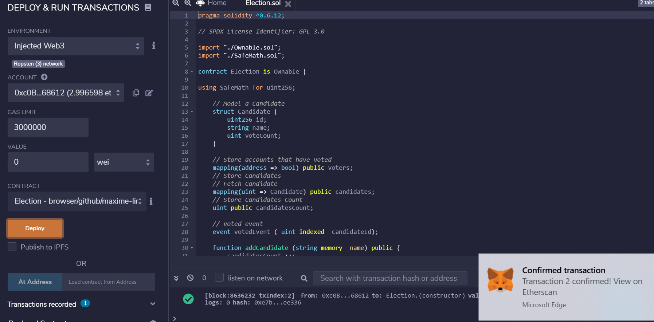

Etherscan déploiement : <https://ropsten.etherscan.io/tx/0xe7bcaa80ff13364c6614e6ca2b63e0cf9bb2c78edb49c9800fdbc4e0124ee336>

m.

Justification frais de transaction différents : lié au frais de transaction a l’instant t.

Adresse public du smart contract : 0x7f89a4d7f8c9c279818bad6b0bbb49a98c538be9

n. Ajouter un candidat :

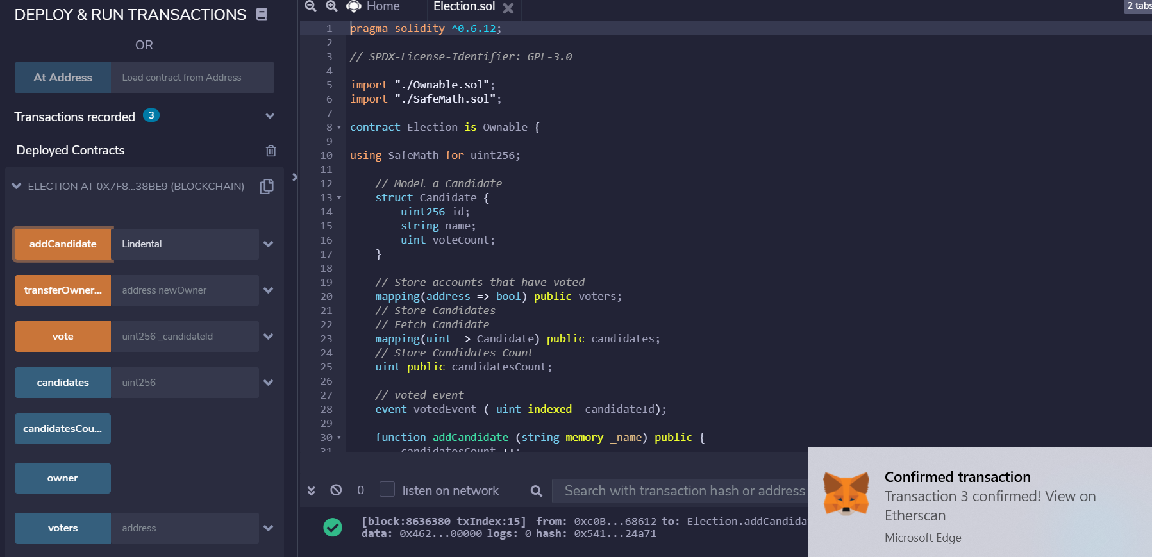

o.

Etherscan ajout candidat : <https://ropsten.etherscan.io/tx/0x541ba3768b08143efe809fb0fd833657b857322aecb5d4b268a4b95f44324a71>

p.

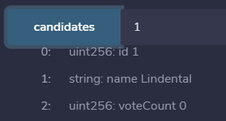

q.

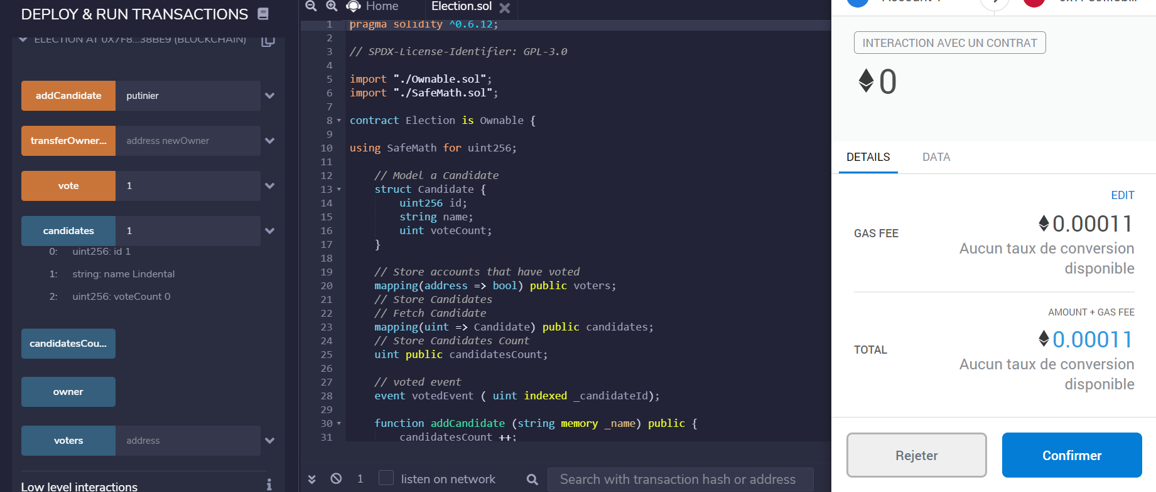

Etherscan : <https://ropsten.etherscan.io/tx/0xf75195ecfbcda13f00b05887f79b2dbb8dcb263b668dcaab01451140d3bd2f15>

r.  
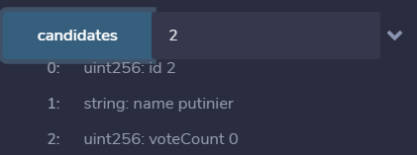

s.

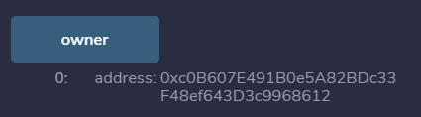

z. en modifiant le code election.sol, public devient public onlyOwner

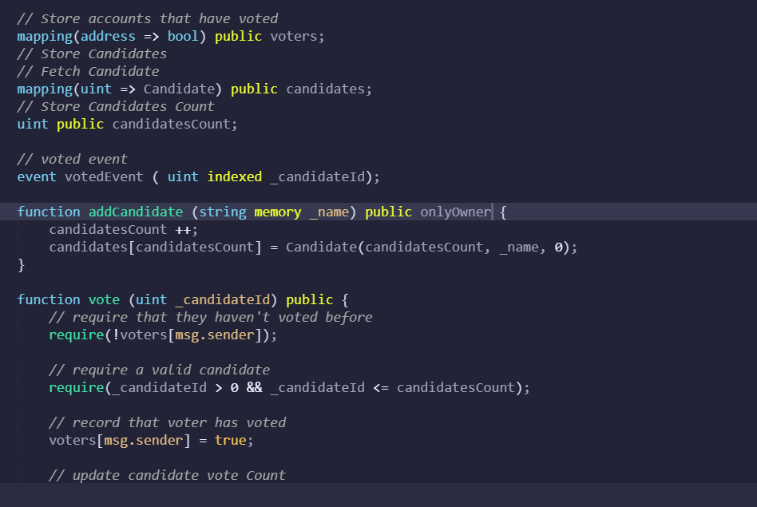

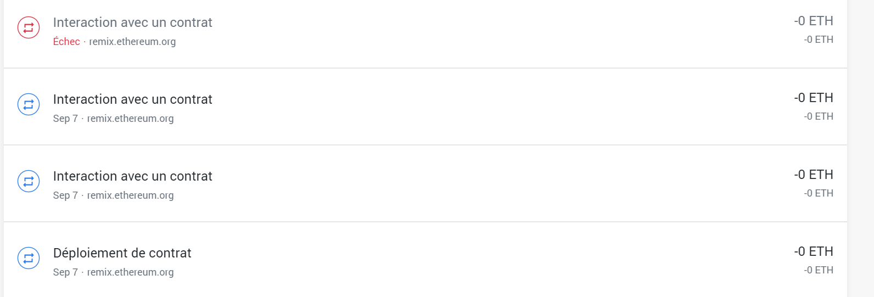

<https://ropsten.etherscan.io/tx/0x081170a18010b150027a60d9815fc610611280a13be16fde007f636cec79fe76>